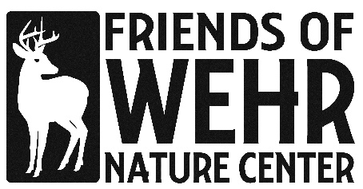

Debra McRae Scholarship for Environmental Studies
The Debra McRae Scholarship for Environmental Studies was created in 2021 to honor Wehr Nature Center’s director Deb McRae upon her retirement after 30+ years of dedicated service to teaching the next generation to love and protect the earth. Deb’s passion for protecting the environment was a hallmark of her career. This scholarship will be awarded annually to a high school senior who has demonstrated a passion for protecting the environment through volunteerism and extracurricular involvement and who plans to pursue a career in an environmental-related field through study at a four-year university program.
Award:
Two $1500 scholarships will be awarded in the 2023/24 school year
Eligibility
To be eligible for the Deb McRae Scholarship for Environmental Studies, applicants must:
- Be a graduating high school senior who has been accepted as a full-time undergraduate degree-seeking student at an accredited 4-year college or university
- Be a current resident of Wisconsin
- Be pursuing a major in a field related to the environment (such as, but not limited to, environmental science, environmental education, environmental engineering, sustainability, natural resources, wildlife conservation, and environmental policy)
- Exhibit dedication to the environment through community service activities and extracurricular involvement
Application Materials
Completed applications with all the required documents must be submitted by the end of the day on April 15, 2024. A complete application will include:
- A completed application form
- A letter of acceptance from an accredited college or university (if available; can be submitted after initial application as a supplemental email)
- A resume listing: community service work, leadership positions, extracurricular activities, honors and awards, work experience, and any coursework relevant to your planned career.
- A letter of recommendation from a non-family member who can write about your environmental-focused coursework, leadership experience, community service, or volunteerism.
- An essay of no more than 500 words that answers the prompt:
“What experiences or life events influenced your interest in nature and the environment? How will your planned career help to protect the environment and benefit future generations? “
Completed applications are due no later than Sunday, April 15, 2024, at 11:59 pm. Submit completed materials to: carol.howard@friendsofwehr.org. Please include “Debra McRae Scholarship for Environmental Sciences” in the subject line.
Awarding Scholarship
- Applicants will be notified of the results by email after April 22. 2024.
- The recipient is requested to attend a Friends of Wehr board meeting to accept their award.
- The scholarship will be made payable directly to the school. The winner is responsible for supplying the scholarship committee with the contact person and address to send payment to no later than June 1.
- Should the recipient not attend school as planned, the check must be returned to the Friends of Wehr by September 30, 2024. A new check will be issued if the recipient attends a different school.

Anti-Discrimination Statement
The Friends of Wehr, Inc. does not discriminate on the basis of race, color, religion (creed), gender, gender expression, national origin (ancestry), disability, marital status, sexual orientation, or any other restricting classification in its selection of scholars.
Eligibility for Deb McRae Scholarship
Family members of Friends of Wehr board members, staff, and scholarship committee members are not eligible for the Deb McRae Scholarship.

For questions or more details about the scholarship please get in touch with Bev Bryant at: beverly.bryant@milwaukeecountywi.gov

Friends of Wehr Nature Center, 9701 W. College Ave, Franklin WI 53132
www.friendsofwehr.org

